HOME PAGE

- 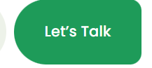 Let’s Build

- Book a Meet Let’s Build

- 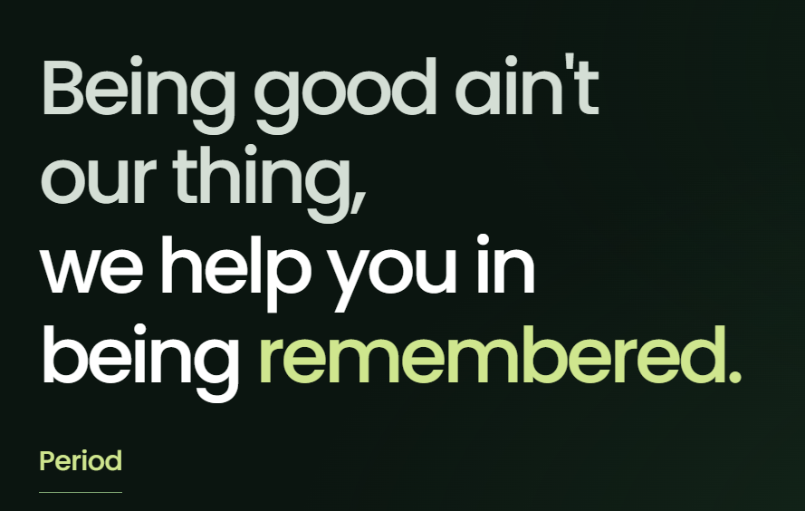 People don’t buy what they don’t notice.
Instead of Period Branding, content, films and digital from a young Hyderabad team that tells you honestly what works.
- 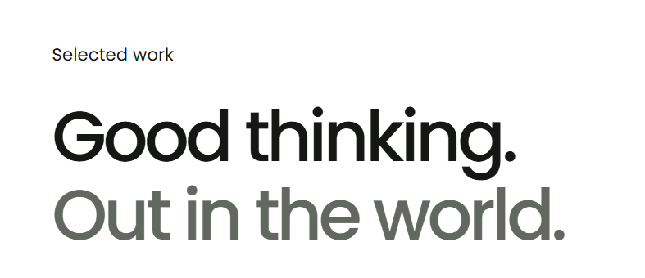 Good thinking deserves to be remembered.
- 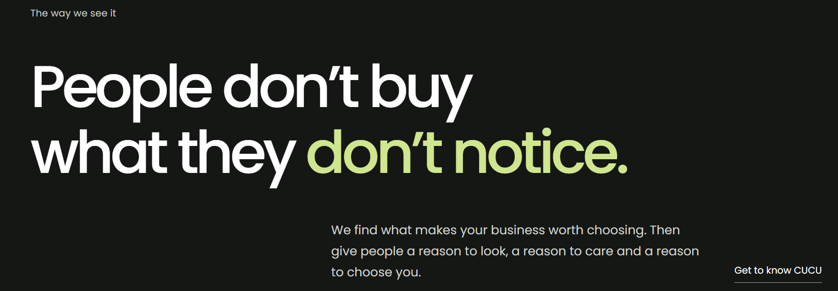 Worth choosing isn’t the same as chosen.

We find what makes your business worth choosing. Then we give people a reason to look, a reason to care and a reason to choose you.
- 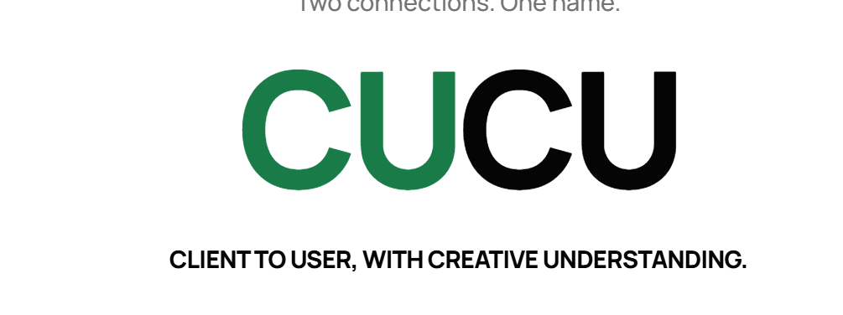Add after services section - only cucu graphic, and a “Read our story” link to the About page. The full story stays on About.
- 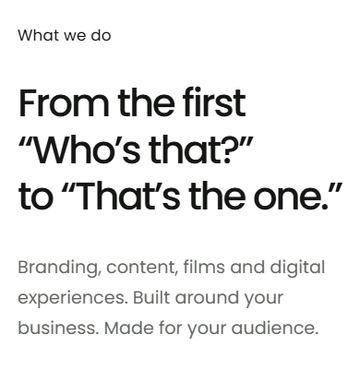 Heading is as it is. Sub: Branding, content, films and digital experiences that turn first impressions into lasting connections.
- 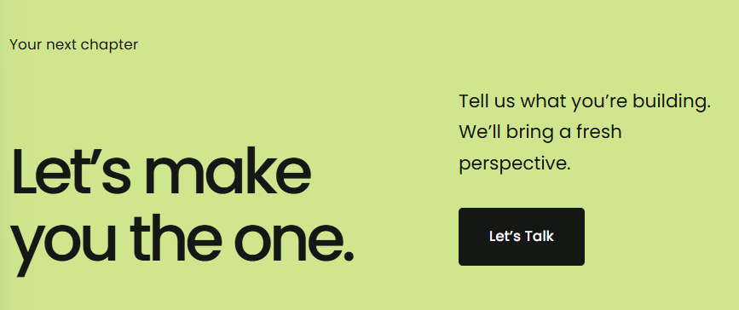 Heading is as it is. Sub: Tell us what you’re building. We’ll help you build it better.
Let’s talk Let’s Build
- 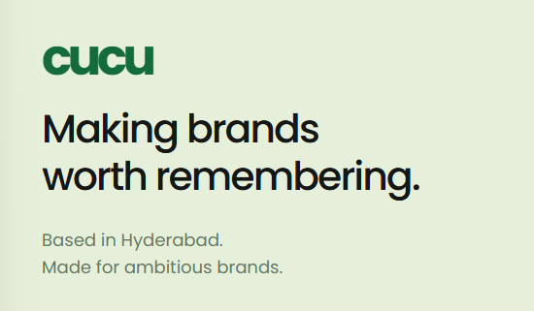 Making brands people notice, remember and choose.
Based in Hyderabad. Made for brands ready to stand out.

ABOUT PAGE
- 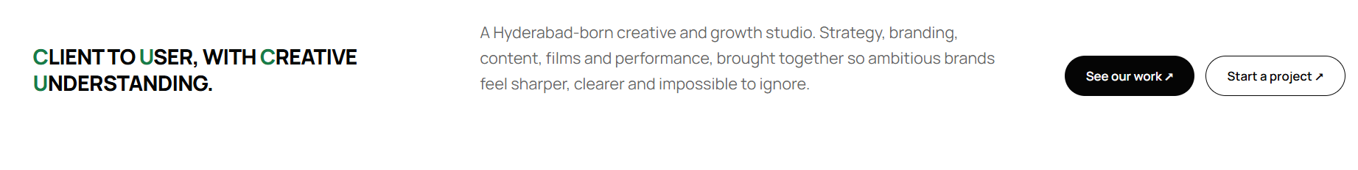 A creative and growth studio from Hyderabad. We bring strategy, branding, content, films and performance together to build brands people notice, remember and choose. Start a project Let’s Build
- 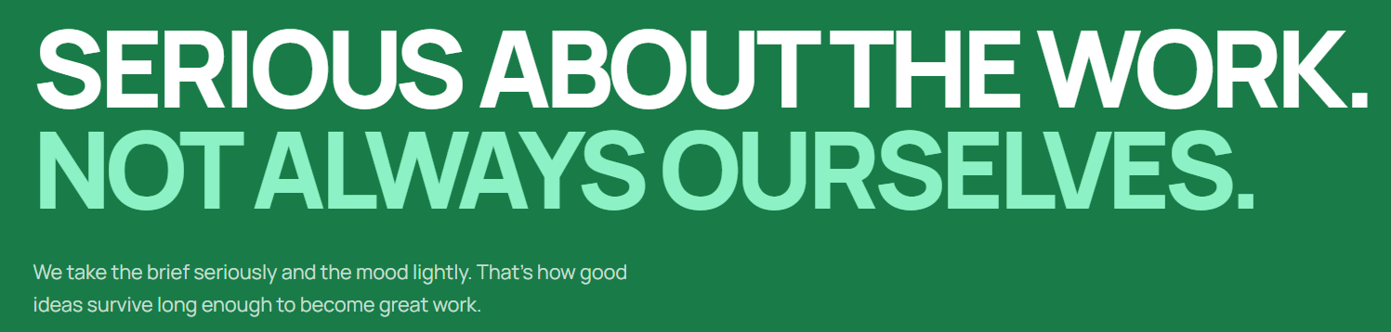 Sub: We take the work seriously, but believe the best ideas come when there’s room to play.
- 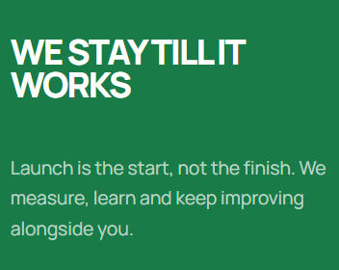 Heading : Good work keeps getting better
- 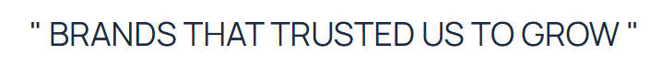 The brands that are part of our story.
- 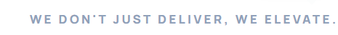 Got something good in mind? Let’s make it
happen then Let’s Connect Let’s Build
SERVICES PAGE
Social Media Marketing
We create content and conversations that give people a reason to stick around.

Performance Marketing
We turn insights into targeted campaigns that help your business grow.

Search Engine Optimization
We help the right people find you when they're looking for what you offer.

Content Creation
From words to visuals, we create content that gets your brand noticed and stays with people.

Ad Films
We bring your brand to life through films that capture attention and leave an impression.

Web Experience
We build digital experiences that look good, work smoothly and make it easier for people to connect with your business.

PORTFOLIO PAGE
The work we've been up to.
Different brands, different challenges, a lot of thinking in between.

